SA Assignment 4

Modeling is an activity which is governed by a process. It is undoubtedly the part of the larger process of architecture-centric software development. However, modeling itself is a sub-process and can vary from project to project. An architectural modeling notation is a language or means of capturing design decisions.

Some critical decisions that architects and other stake holders have to make in developing architecture is to choose:

● The architectural decisions and concepts that should be modeled.

● The level of detail

● The amount of rigor or formality

These decisions should be based on cost and benefits. Architects should balance the benefits of having certain models in certain forms or notations with the costs of creating and maintaining those models. The choice of what to model and at what level of detail will be stakeholder driven. The most important or critical aspects of a system should be the ones that model the greatest detail with the highest degree of rigor.

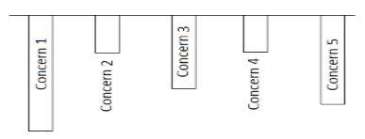

The diagram shows five concerns about the system identified by the stakeholders. Here, the concern 1 is of greater importance and will be modeled deeply. Concerns 2 and 4 are of less importance and will be modeled shallowly. Each project has a different modeling need as the concerns and their relative model of importance varies in each project.

The basic activities behind stake-holder driven modeling are:

1. Identify relevant aspects of the software to model.
2. Roughly categorize them in terms of importance.
3. Identify the goals of modeling for each aspect.
4. Select modeling notations that will model the selected aspects at appropriate levels of depth to achieve the modeling goals.
5. Create the models.
6. Use the models in a manner consistent with the modeling go.